CE213 Class Problem Sheet 3 (Week 4)

Mock paper for Progress Test 1 in Week 6 (on Moodle). Questions about progress test?
(Q1) The diagram below shows a game tree in a two-player board game, in which it is Player One’s turn to make a move. Assume an evaluation function is available that returns an estimate of the value of a position (a node) to Player One and the numbers in the leaf nodes show the results of applying this function to the corresponding board positions. Player One has a choice of three moves: A, B or C. Use the minimax search strategy to determine the best move and state the value that is backed up to the root node.
6
17
11
8
7
9
19
5
12
Move A
Move B
Move C
(Q2) Assume that nodes are considered from left to right. If alpha-beta pruning is used in applying the minimax procedure, which leaf nodes need not be evaluated?
(Q3) Which leaf nodes need not be evaluated using alpha-beta pruning if nodes are considered from right to left.

(Q4) The diagram below shows a game tree in a two-player board game, in which it is Player One’s turn to make a move and the numbers under the leaf nodes show their values (just assume these values are obtained from some heuristics) to Player One. Assume that nodes are considered from left to right. If alpha-beta pruning is used in applying the minimax procedure to this game tree, what would be the value returned to node A and which nodes (including non-leaf nodes) need not be considered for evaluation?
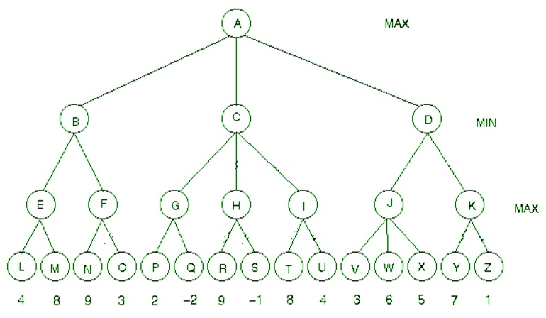
More questions (could be for homework):
1. Will minimax search with alpha-beta pruning return the same value to the root node (current game position) as that returned by minimax search without alpha-beta pruning?

2. How to evaluate game positions for minimax search that doesn’t backtrack from endgame positions?
(e.g., for the 5x5 Tic-Tac-Toe game, backtracking from endgame positions would be too slow)
Topics: minimax search, alpha-beta pruning

Answers or hints:
Q1:
7
6
6
17
11
7
8
7
9
5
19
5
12
Move A
Move B
Move C

Best move: B, value: 7

Q2:
7
6
6
17
11
7
8
7
9
5
?
5
12
Move A
Move B
Move C

The node marked with ? needs not be evaluated.

Q3:
7
6
6
?
?
7
8
7
9
5
19
5
12
Move A
Move B
Move C

The nodes marked with ? need not be evaluated.

Q4: The value returned to node A is 8, as indicated below. The nodes H, I, K, O, R, S, T, U, Y, Z need not be considered for evaluation.
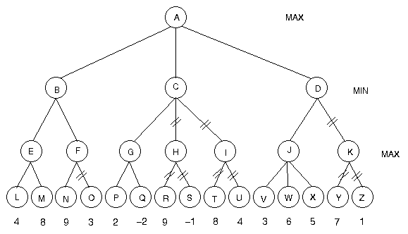
8
9
8
2
2
6
6
8

By using alpha-beta pruning in this example over 1/3 of the nodes can be ignored in the minimax search.

More questions:

Yes. Minimax search with or without alpha-beta pruning will return the same value to root node. Alpha-beta pruning only improves the speed of minimax search.

For the 5x5 Tic-Tac-Toe game, a simple game position evaluation function could be defined as follows (may not be the best):

There are 12 possible win situations: 5 horizontal lines, 5 vertical lines, 2 diagonal lines, with the whole line occupied by one player only.

Assume the AI player is ‘X’.
If a line has both ‘X’ and ‘O’, the value of this line to AI player is 0.
If a line has n ‘X’s, but no ‘O’, the value of this line to AI player is 10^{n}, e.g., 10 (n=1), 10000 (n=4).
If a line has n ‘O’s, but no ‘X’, the value of this line to AI player is -10^{n}, e.g., -10 (n=1), -10000 (n=4).
The value of a game position to AI player can be defined as the sum of values of the 12 lines to AI player.

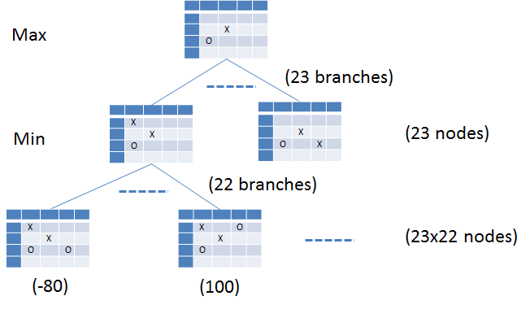
Examples of non-endgame positions:
O
X
The value to AI player is 10+10-10-10-10 = -10
X
O
The value to AI player is 10+10+10-10-10 = 10
 | X
 |  | X
 | O |  | O
The value to AI player is 10+10+10-100-10 = -80
 | X |  | O
 |  | X
 | O
The value to AI player is 100+10+10-10-10 = 100
 | X |  | O
 |  | X
 | O | X | O
The value to AI player is 100+10-100 = 10

Examples of endgame positions:

X | O | X | O | O
O | X | X | O | X
O | X | X | O | X
O | O | X | O | X
X | O | X | X | O
‘win’ endgame, its value to Player ‘X’ is +10⁵ or just some positive number

X | O | X | O | O
O | X | X | O | X
O | X | X | O | X
O | O | X | O | X
X | X | O | O | O
‘loss’ endgame, its value to Player ‘X’ is -10⁵ or just some negative number

O | O | X | O | O
O | X | X | O | X
O | X | X | X | X
O | O | X | O | X
X | X | O | O | O
‘draw’ endgame, its value to Player ‘X’ is 0

